Beet Sprout

1. Beetroot

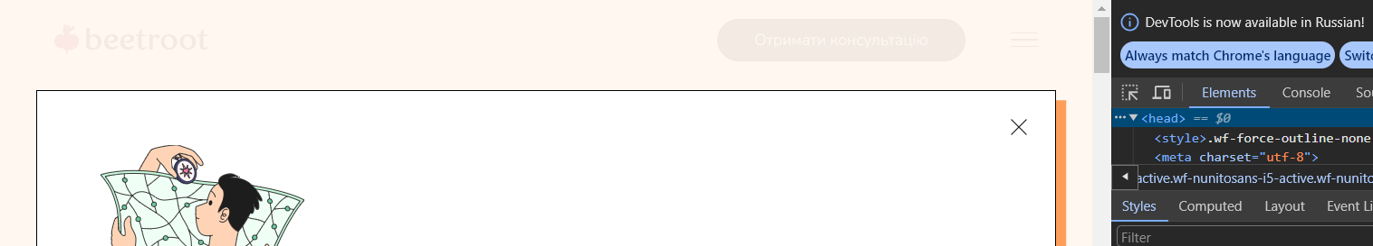

**UTF-8**

2. Microseniors

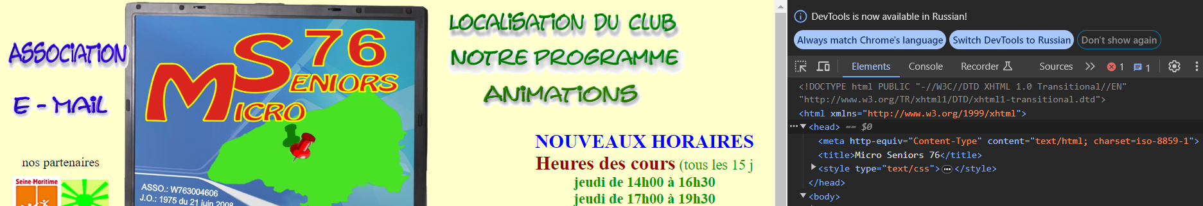

**Content-Type**

3. Tennis

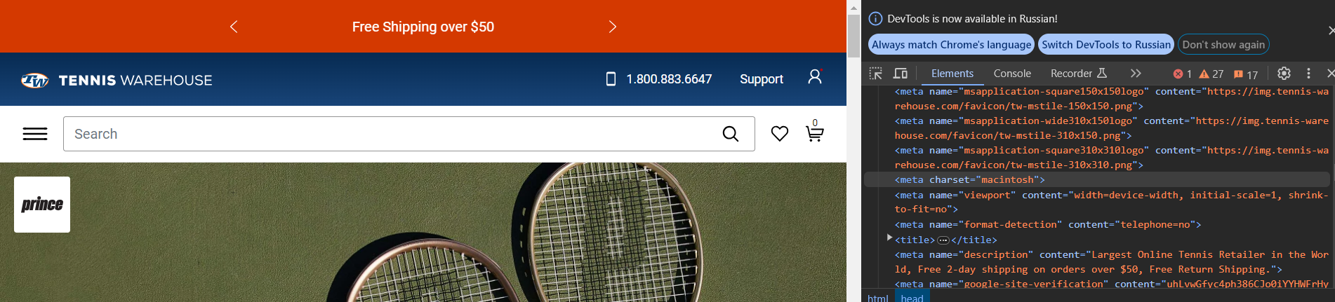

**macintosh**

4. Fidelity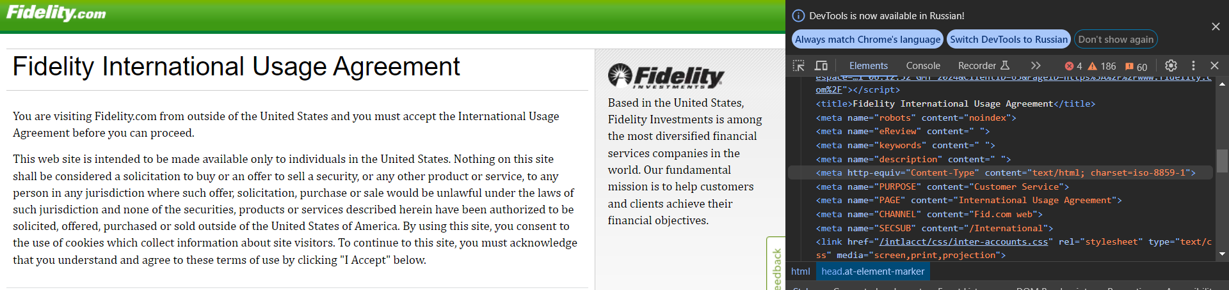

**Content-Type**